Survey Test Case

Test case records the result of a test. There are different formats of test cases used by different companies but there must be some mandatory fields that must be included in the test case. Spend around 15 – 20 minutes to search and observe different formats of test cases and identify the mandatory fields. List and explain these fields.

Test Case for White Box Testing

This practical aims at providing practice for the students to create test cases by following a template provided.

Study the following codes:

import java.util.Scanner;
class DecimalToOctalExample
{
public static void main(String args[])
{
Scanner input = new Scanner( System.in );
System.out.print("Enter a decimal number : ");
int num =input.nextInt();

/* Method 1:
* Using predefined method toOctalString(int)
* Pass the decimal number to this method and
* it would return the equivalent octal number
*/
String octalString = Integer.toOctalString(num);
System.out.println("Method 1: Decimal to octal: " + octalString);

/* Method 2:
* Writing your own logic: Here we will write
* our own logic for decimal to octal conversion
*/

// For storing remainder
int rem;

// For storing result
String str="";

// Digits in Octal number system
char dig[]={'0','1','2','3','4','5','6','7'};

while(num>0)
{
rem=num%8;
str=dig[rem]+str;
num=num/8;
}
System.out.println("Method 2: Decimal to octal: "+str);
}
}
(https://beginnersbook.com/2014/07/java-program-for-decimal-to-octal-conversion/)

- Identify the test cases from the codes. For example; TC: To test the result of decimal to octal conversion.

- Based on the test cases identified, create THREE test cases (positive and negative test cases). Your test case format MUST follow the provided test case template below.

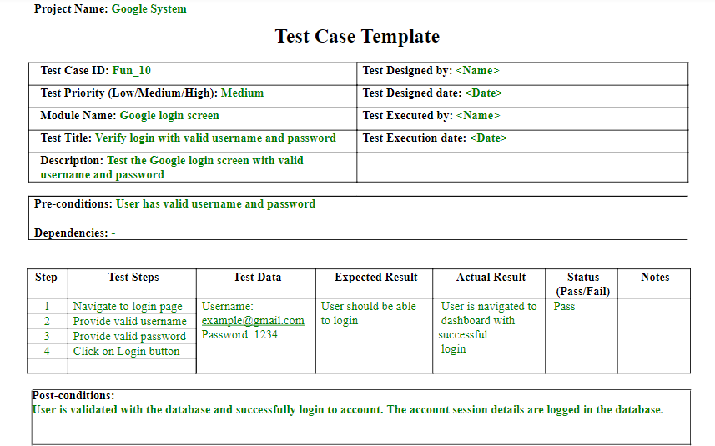
Figure 1: Test Case Template

